
January, 2023

Report
Network Design

Bachelor of Computer Application

Mr. Rojan Poudel

Table of Contents
1. Introduction 1
2. Network Topology 1
3. LAN Design 2
4. IP Addressing and Subnetting 4
5. Network Security 4
6. Ethical Considerations 5
7. Hardware 5
8. Conclusion 6
9. References 6

Table of Figures

Figure 1: WAN Topology of NovaVision Solutions 2
Figure 2: LAN Design for Branch Offices 3

1. Introduction
NovaVision Solutions is a fast-growing international software and cloud services company based in Melbourne, Australia, with new branch offices opening in Sydney, Perth, and Kuala Lumpur (Malaysia). The growing organization needs a robust, scalable, and secure network infrastructure to cater to day-to-day operations, collaboration between branches, and cloud-based services.
Each branch has a six-story building with a server room on the fourth floor where eight servers are placed. Key networking requirements include Internet access that is highly available, inter-branch communication that is secure and better utilization of IP addresses along with effective cybersecurity controls. The report contains a network design solution covering topology selection, LAN and WAN design, VLSM-based IP addressing, security consideration, ethics, and privacy compliance. The objective of the solution design is to be cost-effective, scalable, and compliant with professional standards and legal requirements.

2. Network Topology
A hybrid network topology has been selected for NovaVision Solutions. Internally, each office uses a star topology for local area networking, while externally, a hub-and-spoke WAN topology is implemented with Melbourne headquarters acting as the central hub.
This design was chosen for the following reasons:
- Scalability: Additional branches can be integrated easily without major redesign.
- Fault isolation: Failures within one branch LAN do not affect other branches.
- Security: Centralized control at the headquarters allows for consistent security policies.

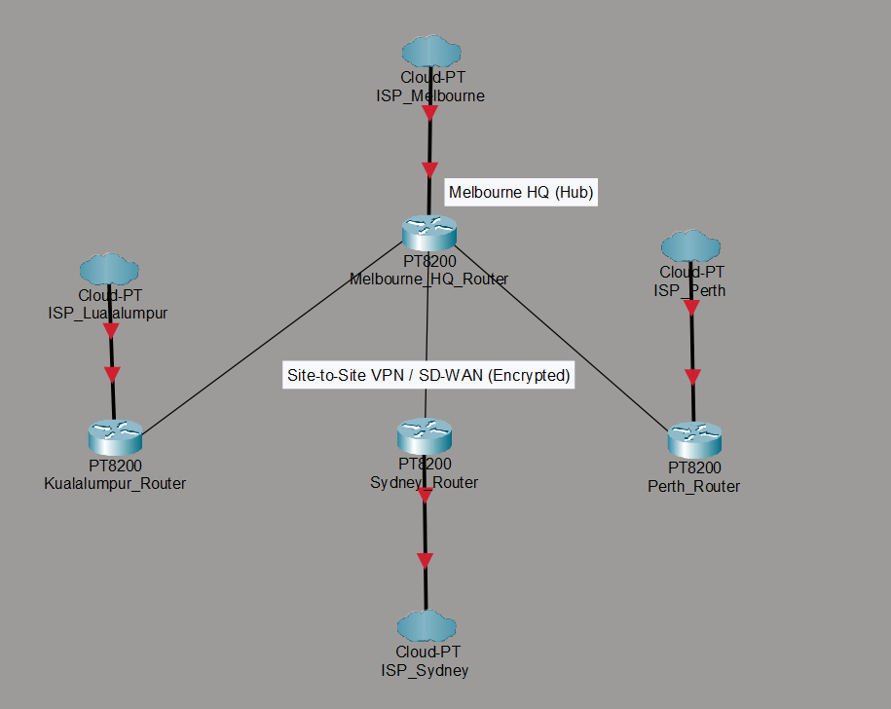
Figure 1: WAN Topology of NovaVision Solutions

3. LAN Design
Each of the branch offices has exactly the same LAN design, making managing and maintaining it a lot easier. The internal network is segmented into logical areas: users, servers, and network management.
Components of LAN:
- Access Layer: Layer-2 switches connecting end-user devices on each floor
- Distribution/Core Layer: Layer-3 switches for inter-VLAN routing
- Server Segment: This will be a dedicated VLAN for servers that are located on the fourth floor.
- Edge Security: Firewall placed between LAN and WAN router
- Internet/WAN Router: Connects the branch LAN to headquarters and to the Internet
This hierarchical LAN design improves performance, enhances the security through segmentation of the network, and supports future expansion.
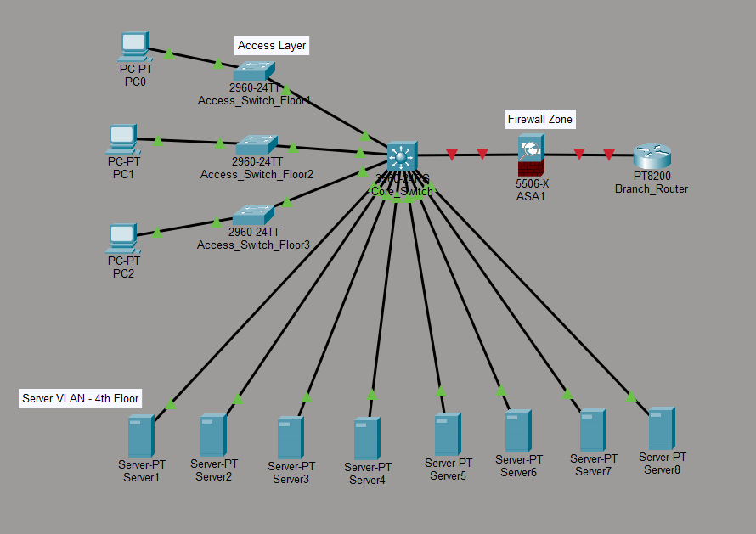
Figure 2: LAN Design for Branch Offices

4. IP Addressing and Subnetting
NovaVision Solutions has been allocated the private IP address range 172.61.0.0/16. A Variable Length Subnet Masking (VLSM) approach is used to optimize IP address usage while allowing room for future growth.
User Allocation (Set 2):
- Melbourne: 3950 users
- Sydney: 2785 users
- Perth: 1685 users
- Kuala Lumpur: 2255 users
Subnets are allocated from largest to smallest to maximize efficiency.
Summary of IP Allocation:
Location | Network Address | Subnet Mask
Melbourne HQ | 172.61.0.0 | /20
Sydney | 172.61.16.0 | /20
Kuala Lumpur | 172.61.32.0 | /21
Perth | 172.61.40.0 | /21
Detailed subnet calculations, usable IP ranges, and broadcast addresses are provided in Appendix A.

5. Network Security
To secure the organization from cyber attacks, a layered security strategy is put in place.
Identified Threats:
- Distributed Denial of Service (DDoS)
- Phishing Attacks
- Ransom
- Data breaches
Security Controls:
- Next-generation firewalls in each location
- IDS/IPS systems for malicious traffic detection
- Use of VLANs for network segmentation
- Site-to-site VPN or SD-WAN with encryption for inter-branch communication
- Multifactor Authentication (MFA) for Administrative Access
Restrictive Policies:
- Server rooms that can be accessed by authorized IT personnel only
- Role-Based Access Control (RBAC)
- Continuous Security Monitoring and Logging

6. Ethical Considerations
The Australian Computer Society Code of Professional Ethics provides a framework with regard to professional responsibilities to protect systems and data. The relevant tenets are: Public Interest, Professional Competence, Protection of Privacy.
The relevant IT professionals who design or manage the NovaVision data network have a similar ethical commitment to secure customer and organizational data from unauthorized access. Such ethical judgment affects direct efforts at secure data network design, correct security measure implementation, or adherence to legal guidelines or regulations. Lack of proper security measure implementation can thus lead to breaches of data security or failure to fulfill ethical mandates.

7. Hardware
The hardware that is recommended is:
Routers - Enterprise Routers for WAN Networks
Switches - Layer-2 Access Switches, Layer-3 Core Switches
Firewalls: Next generation firewalls with IDS/IPS functionalities
Cabling: Cat 6 cable for Ethernet LAN, fiber optic cable for backbone connectors
These components are chosen to ensure that the system is reliable, has a high level of performance, and can allow for future.

8. Conclusion
The report has given a detailed network design for NovaVision Solutions to cater to scalability, security, and compliance issues efficiently. The implementation of a hybrid model network, VLSM IP addressing, robust security measures, and ethical best practices will help the business efficiently cope with the increasing workload.
It is recommended that NovaVision monitor its security policies from time to time, keep its security hardware up-to-date based on technological advancements, and perform compliance audits. One important thing that has been realized is that planning for a network helps reduce future operations risks.

9. References
Australian Computer Society (ACS), ACS Code of Professional Ethics, ACS, Australia.
Tomsho, G. (2020). Guide to Networking Essentials. 8th ed. Cengage Learning.
Stallings, W. (2022). Network Security Essentials. Pearson.
Australian Government, Australian Privacy Principles (APPs).
Malaysia Government, Personal Data Protection Act (PDPA).

Appendix A - VLSM Calculations and Subnet Tables
VLSM calculations for NovaVision Solutions (IP Range: 172.61.0.0/16)
Step 1: Determine Hosts and Subnet Sizes
Branch | Users | Hosts Needed (+2) | Subnet Mask | Max Hosts
Melbourne HQ | 3950 | 3952 | /20 | 4094
Sydney | 2785 | 2787 | /20 | 4094
Kuala Lumpur | 2255 | 2257 | /21 | 2046
Perth | 1685 | 1687 | /21 | 2046

Step 2: Allocate Subnets Using VLSM
Branch | Network Address | Subnet Mask | Usable IP Range | Broadcast Address | Max Hosts
Melbourne HQ | 172.61.0.0 | 255.255.240.0 (/20) | 172.61.0.1 - 172.61.15.254 | 172.61.15.255 | 4094
Sydney | 172.61.16.0 | 255.255.240.0 (/20) | 172.61.16.1 - 172.61.31.254 | 172.61.31.255 | 4094
Kuala Lumpur | 172.61.32.0 | 255.255.248.0 (/21) | 172.61.32.1 - 172.61.39.254 | 172.61.39.255 | 2046
Perth | 172.61.40.0 | 255.255.248.0 (/21) | 172.61.40.1 - 172.61.47.254 | 172.61.47.255 | 2046

Appendix C - Security and Access Control Policies
Policy Name | Description | Applicable To
Server Room Access | Only IT administrators may enter server rooms | All branches
Firewall Rules | Block all incoming traffic except required services | All branches
VLAN Segmentation | Users, servers, and management networks are separate | All branches
VPN Encryption | Inter-branch communication uses AES-256 VPN | HQ Branch
MFA for Admin Access | Admin accounts require multi-factor authentication | All branches
Role-Based Access | Users have access only to assigned resources | All branches
Continuous Monitoring | Network traffic logged and monitored continuously | All branches

